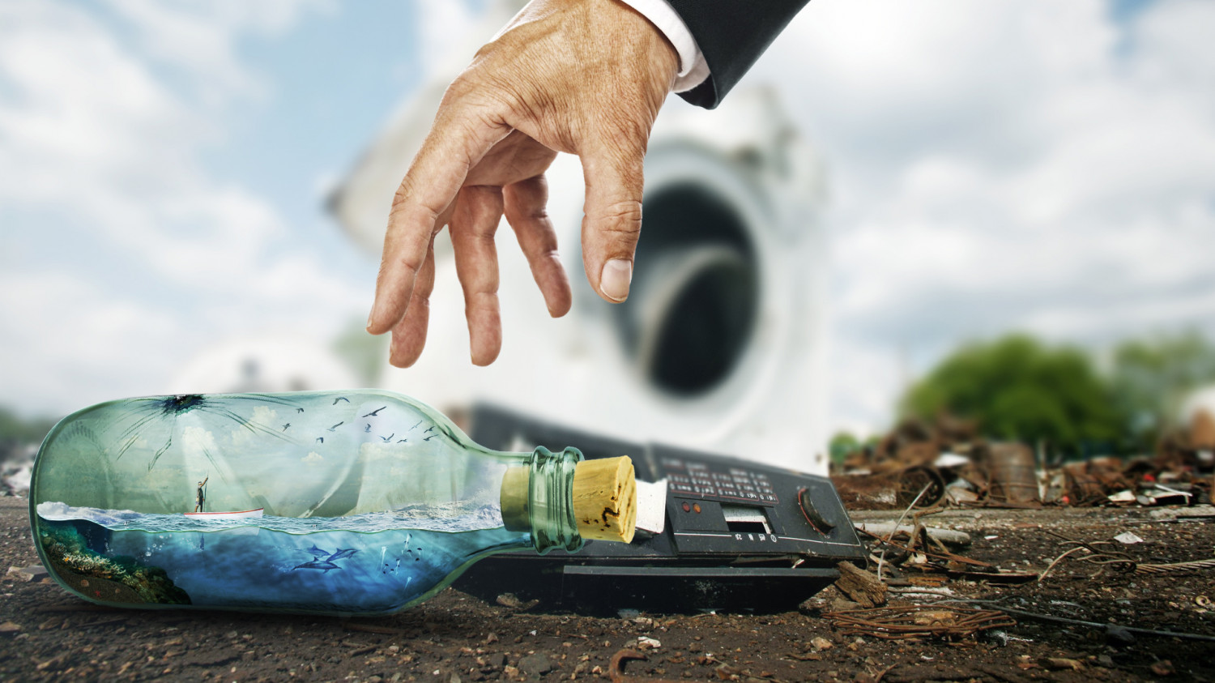

This image seems like it used the selection tools to take elements from multiple images to form a composite scene from them. The specifics of how the water scene was put into the bottle are beyond me, but it looks impressive.

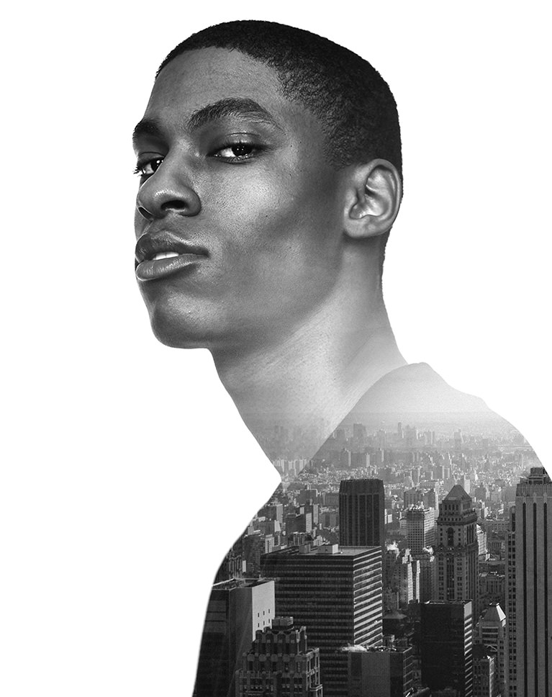

In this image it looks like some sort of layer mask was used to fit the image of the city into the shape of the person’s upper body. I think the gradient tool and a layer mask was probably used to make the transition from his face to the city.

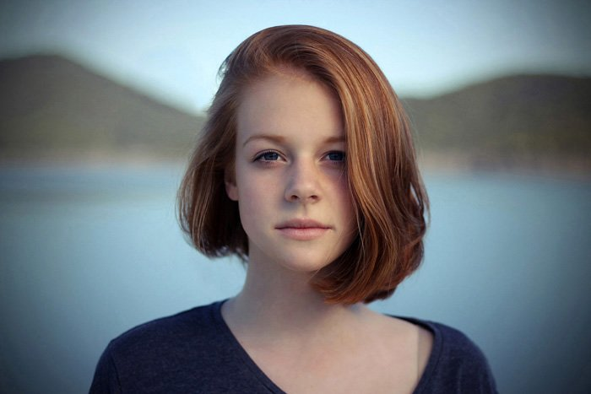

This image looks simpler than the others to create, although hair, especially long hair, can be difficult to select correctly. This probably only required the selection tools and a blur filter.